Conflict of Interest Disclosure

Manuscript No. ( 2170-1 )

Manuscript Title:
An Improved Algorithm for Congestion Management in Network Based on Jitter and Time To Live Mechanism
The author/s whose names are listed below herewith certify that they are not involved or affiliated with any organization or entity for political, financial, professional relationships or personal motives in the subject matter, materials used and materials discussed in their manuscript submitted to
Al-Nahrain Journal for Engineering Sciences.

If the author/s have a corporation, an entity, or an institution which have sponsored their research, please acknowledge those sponsors herewith, stating each of the entities’ names and the type of sponsorship they provided (such as financial aid, laboratories, materials, supervision, …etc):
__________________________________________________________________________________________________________________________________________________________________________________________________________________________________________________________________________________________________________________________________________________________________________________________________________________________________________________________________________________________________________________________________________

The following authors confirm that all the above information provided herewith are true and corrects.

Author/s name/s:
Author’s Name | Signature | Date
1. Samar Taha Yousif | 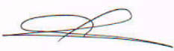 | 2020/ 9/ 29
2. Zaid Abass Fadahl Al-haboobi | 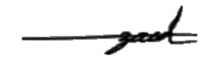 | 2020/ 9/ 29
3.
4.
5.

